**CHAPTER THREE**

**Methodology and Design**

**3.1 Introduction**

A methodology is a formal study or inquiry, especially to unveil new facts or information; thus, research methodology should be good enough to enable the attainment of the specified objectives, which are accomplished through the use of specific components such as data collection and design requirements, and system modeling (use case, activity, and class diagrams). This chapter describes the input/output specifications as well as the system requirements for the currently under-development of a computerized loan record management system.

**3.2 Methods of Data Collection**

Before constructing any system, collecting data and facts about the existing system is necessary to comprehend what is going on. Two approaches were used in this study.

1. Observation of the Work Environment
2. Documentation

**3.2.1 Observation of the Work Environment**

This approach was used to collect information and data for this study by observing how the manual system functioned. Detailed inspection revealed the most obvious weaknesses in the present system. The setting in which the observation is made can be altered in a variety of ways when using the observational approach.

**3.2.2 Documentation**

Documentation is a sort of secondary data collection. This strategy takes the use of journals, manuals, previous work, publications, and other sources. This form of data collecting is chosen because it allows for comparison with previous research. This includes the internet, which is a data-collecting tool. The internet was utilized to find information about tough or unclear subjects.

**3.3 System Modeling**

A system model is a conceptual model resulting from system modeling that describes and represents a system. It is an interaction between a set of components that work together to achieve a common purpose. Visual models of object-oriented software-intensive systems may be created utilizing a set of visual notation techniques included in the Unified Modeling Language, which is used in the development of this modern system. UML diagrams utilized in this new design include use case diagrams, class diagrams, and activity diagrams.

**3.3.1 Use Case Diagrams**

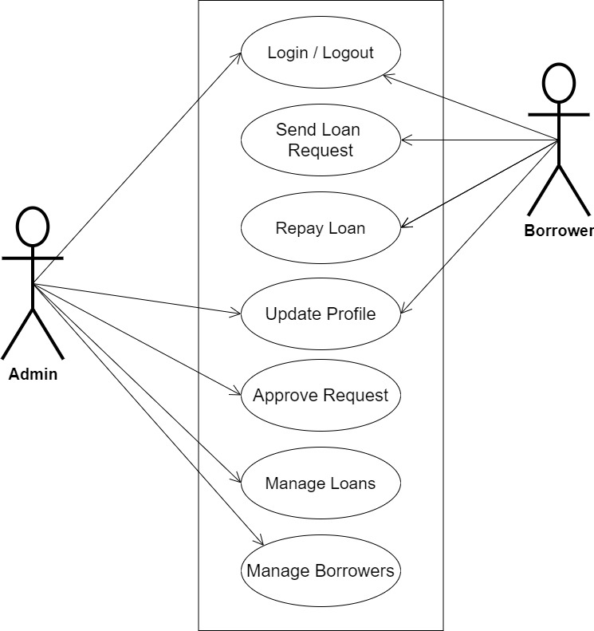

**Fig 3.1 System Use Case Diagram**

**3.3.2 Class Diagrams**

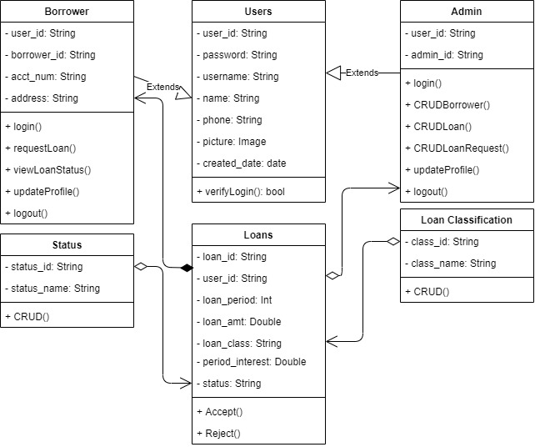

**Fig 3.2 System Class Diagram**

**3.3.3 Activity Diagrams**

**Login**

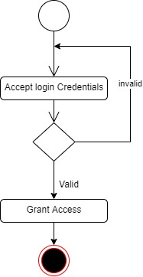The process for gaining access to the system is depicted in the diagram below; the username and password must be accurate to gain access.

**Fig 3.3 System Login Activity Diagram**

**Request Loan**

The process for requesting a loan is depicted in the diagram below; The system ensures that the user is authenticated and has an updated profile to perform the request.

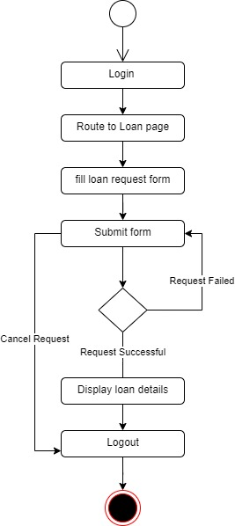

**Fig 3.4 Request Loan Activity Diagram**

**Approving Loan**

The process for approval of loans is depicted in the diagram below; The system ensures that the user is authenticated and authorized to approve loans for credibility purposes.

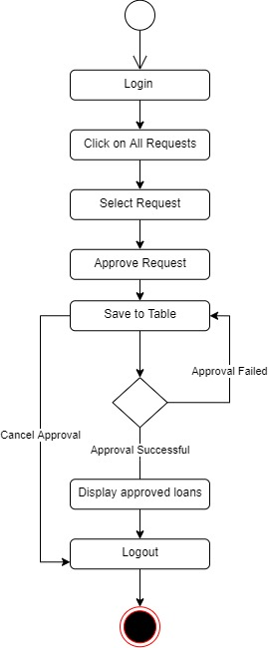

**Fig 3.5 Approve Loan Activity Diagram**

**3.4 Database Design**

The following are some of the input specifications used in this project work.

1. Users Table: contains the generic information of all system users.
2. Loans Table: contains every system-registered loan information.

**Table 3.1 Users Input Specification Table**

|  |  |  |  |  |  |
| --- | --- | --- | --- | --- | --- |
| **Field Name** | **Data Type** | **Null** | **Key** | **Length** | **Description** |
| user_id | Varchar | No | PK | 32 | Unique string for identifying users |
| username | Varchar | No |  | 20 | Unique name for users |
| password | Varchar | No |  | 128 | User Password |
| phone | Varchar | No |  | 11 | User phone number |
| name | Varchar | No |  | 100 | User full name |
| picture | Varchar | No |  | 100 | User profile picture |
| nin | Varchar | No |  | 11 | User NIN |
| bvn | Varchar | No |  | 11 | User BVN |

**Table 3.2 Loans Input Specification Table**

|  |  |  |  |  |  |
| --- | --- | --- | --- | --- | --- |
| **Field Name** | **Data Type** | **Null** | **Key** | **Length** | **Description** |
| loan_id | Varchar | No | PK | 32 | Unique string for identifying citizens |
| user_id | Varchar | No |  | 10 | Reference to the User table |
| loan_period | Integer | No |  | 60 | Loan period |
| loan_amt | Double | No |  | 60 | Loan amount |
| loan_class | Varchar | No |  | 60 | Classification of Loan |
| period_interest | Double | No |  | 60 | Loan period interest |
| status | Varchar | No |  | 60 | Loan status |

**3.5 Output Design**

This declares and displays the outcome of the given input. This system's output is dependent on its input. The output specification is listed below.

**Table 3.3 Users** **output design table**

**Table 3.4 Loans** **output design table**

|  |  |  |  |  |  |
| --- | --- | --- | --- | --- | --- |
| **user_id** | **username** | **phone** | **Name** | **NIN** | **BVN** |
| XXXX | XXXX | XXXX | XXXX | XXXX | XXXX |
| XXXX | XXXX | XXXX | XXXX | XXXX | XXXX |
| XXXX | XXXX | XXXX | XXXX | XXXX | XXXX |
| XXXX | XXXX | XXXX | XXXX | XXXX | XXXX |

|  |  |  |  |  |  |  |
| --- | --- | --- | --- | --- | --- | --- |
| **loan_id** | **user_id** | **Loan_period** | **Loan_amt** | **Loan_class** | **Period_interest** | **Status** |
| XXXX | XXXX | XXXX | XXXX | XXXX | XXXX | XXXX | |
| XXXX | XXXX | XXXX | XXXX | XXXX | XXXX | XXXX | |
| XXXX | XXXX | XXXX | XXXX | XXXX | XXXX | XXXX | |
| XXXX | XXXX | XXXX | XXXX | XXXX | XXXX | XXXX | |

**3.6 Input & User Interface Design**

This is a graphic depiction of the system interface; it will be designed to be user-friendly, responsive, and visually beautiful. Furthermore, it will be appropriately safeguarded, thus authorization will be required to see certain levels of the information. To help with the designs, a mid-fidelity wireframing program called Draw.io is employed.

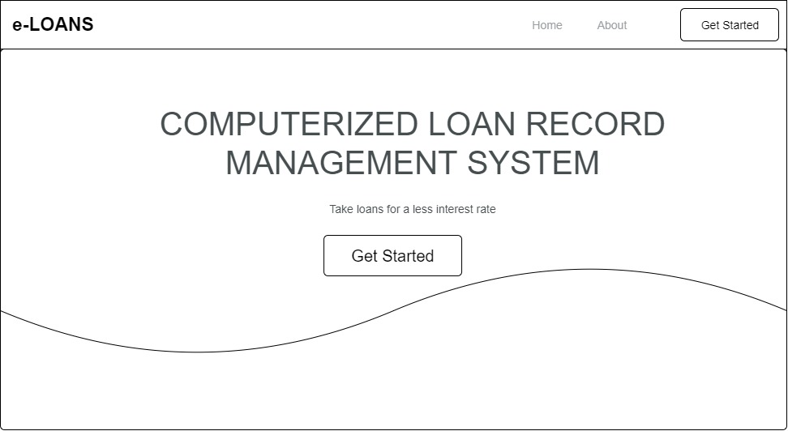

**Fig 3.6 Home Page**

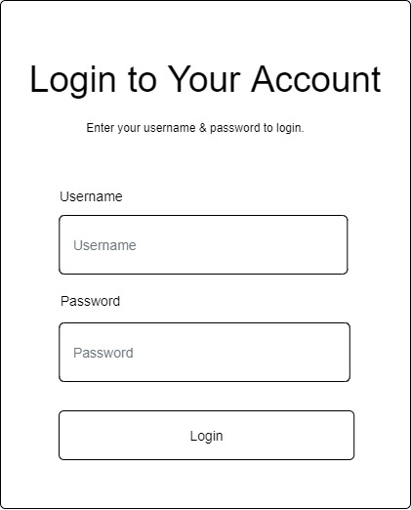

**Fig 3.7 Login Form**

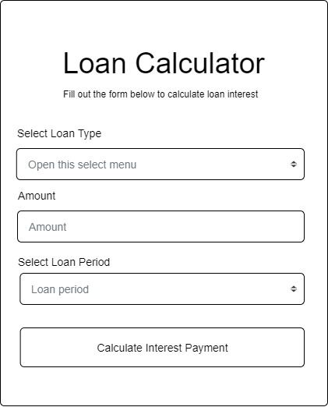

**Fig 3.8 Loan Calculator Form**

**3.7 System Requirement**

Every software system built has a stated system requirement on which it is meant to execute for the best performance. The system requirements, on the other hand, are the bare minimum of hardware and software required for the system to work properly.

**3.7.1 Hardware Requirement**

System Hardware Requirement Include:

1. Minimum of 2 GB of RAM (Random Access Memory).
2. Minimum of Intel Dual core processor.
3. Minimum of 250GB HDD (Hard Disk Drive).

**3.7.2 Software Requirement**

The software requirements include:

1. At least windows 7 OS (Operating System).
2. Vs. Code IDE installation.
3. Browsers include Chrome and Firefox.

**3.8 Choice of Programming Language**

This study will be a web-based application based on the design of a relational database (SQLite). HTML (hypertext markup language), CSS (cascading style sheet), and JavaScript will be utilized for front-end development, while Django (Python) will be used for back-end programming.